
AN ANDROID APPLICATION FOR KEEPING UP WITH THE LATEST HEADLINES
A PROJECT REPORT
Submitted by,
V.NARMATHA - 812022104050
V.PARKAVI - 812022104052
R.PRASIDHA - 812022104053
M.MANJULA - 812022104307
BACHELOR OF ENGINEERING
IN
COMPUTER SCIENCE AND ENGINEERING
M.A.M COLLEGE OF ENGINEERING AND TECHNOLOGY,TRICHY

TABLE OF CONTENTS
1. ABSTRACT
2. INTRODUCTION
3. OBJECTIVES OF PROJECT
4. SCOPE AND LIMITATIONS OF THE PROJECT
5. ANALYSIS
5.1 DETAILED STATEMENT OF THE PROBLEM
6. REQUIREMENT SPECIFICATION
6.1 SOFTWARE REQUIREMENTS
6.2 HARDWARE REQUIREMENTS
6.3 FUNCTIONAL REQUIREMENTS
7. USE CASE DIAGRAM
8. ARCHITECTURE DIAGRAM
9. ADDING REQUIRED DEPENDENCIES
10. ADDING PERMISSION
11. CREATING THE DATABASE CLASSES

12. CREATING API SERVICE AND REQUIRED CLASSES FOR INTEGRATING API
13. BUILDING APPLICATION UI AND CONNECTING TO DATABASE
14. MODIFYING ANDROID MAINFEST.xml
15. RUNNING THE APPLICATION
16. IMPLEMENTATION
17. CONCLUSION
18. REFERNCES

- ABSTRACT
One-Stop Destination for Breaking News Android News Application is the ultimate app for those who want to stay on top of breaking news stories. With real-time updates and alerts, you can be the first to know about the latest events from around the world. Our app aggregates news from top sources to ensure you get the most accurate and up-to-date information.

- INTRODUCTION

  - Preface
In the era of smartphones and digital devices, people have become accustomed to getting their news and information from online sources. Android news apps have emerged as a convenient and reliable way for people to stay informed about current events, breaking news, and other information from around the world. The Android News application is a mobile application designed to provide users with access to the latest news from over 120 newspapers from 50+ countries. The app is designed to be user-friendly, with a visually appealing and easy-to-navigate interface. With the increasing use of mobile devices and the internet, the need for fast and easy access to news articles has become essential. The Android News application aims to bridge the gap by providing users with instant access to the latest news articles from around the world.The Android News application is designed to provide users with access to the latest news from around the world in a fast and convenient manner. With a wide range of newspapers from different countries and a user-friendly interface, the app is an ideal way to stay informed and up-to-date on current events.The Android news app was developed using the Java programming language and the Android Studio IDE. The app utilizes various technologies such as MySQL for the database management, Retrofit for API integration, and Firebase for push notifications. The app's UI is designed using XML and Material Design guidelines.

  - Statement of Problem
One research paper titled "Design and Implementation of News Recommendation System for Android Applications Based on Big Data Analysis" addresses the problem of information overload in news apps [1]. With the increasing amount of news available, users are often overwhelmed and struggle to find relevant content. This paper proposes a news recommendation system that utilizes big data analysis to recommend personalized news articles to users based on their interests and reading history. The system considers various factors such as user demographics, browsing history, and social media interactions to provide a more personalized news experience. The paper presents a case study to demonstrate the effectiveness of the recommendation system and its potential to enhance user engagement and satisfaction with news applications.The paper aims to address the problem of low user engagement in news applications by proposing a personalized news recommendation system that takes into account user interests and preferences, and delivers relevant and diverse news articles.
- OBJECTIVES OF PROJECT
The objectives of android news apps are closely related to the goals of providing users with convenient and personalized access to high-quality news and information, building trust and credibility, promoting diversity and inclusion, and addressing issues of accessibility and privacy. These objectives are all focused on meeting the needs and preferences of users while also ensuring that the news and information presented through the app is accurate, reliable, and trustworthy. By achieving these objectives, android news apps can provide users with a valuable service while also contributing to the growth and success of the journalism industry in the digital age
The objectives of android news apps can be summarized as follows:
1. Provide users with convenient and personalized access to high-quality news and information.
2. Build trust and credibility by ensuring that the news and information presented through the app is accurate, reliable, and trustworthy.
3. Promote diversity and inclusion by exposing users to a variety of perspectives and viewpoints.
4. Address issues of accessibility by reaching underserved communities and ensuring that everyone has access to high-quality news and information.
5. Protect user privacy and data security by implementing robust security measures and respecting user privacy.
6. Support the growth and success of the journalism industry by providing a platform for news publishers and content creators to reach a larger and more diverse audience.
7. Innovate and adapt to changing user needs and preferences in order to stay relevant and continue to provide value to users.

- SCOPE AND LIMITATIONS OF THE PROJECT
  - scope
The scope of the Android news app with augmented reality technology is to provide users with an innovative and engaging way to consume news and information. The app aims to enhance the user experience by integrating augmented reality technology, which allows users to interact with news articles in a more immersive and personalized way. The app's scope includes features such as 3D models, animations, and multimedia content that can be accessed through the user's mobile device [5]. Additionally, the app aims to provide users with access to news from a variety of sources, including newspapers, websites, and social media platforms, to ensure that users have access to the latest and most relevant news content. The app's scope also includes the implementation of advanced algorithms and machine learning techniques to personalize the user's news feed based on their preferences and interests. Overall, the scope of the Android news app with augmented reality technology is to provide users with a unique and interactive way to consume news and information while also keeping them informed and engaged.
The scope of work for an android news app can be divided into several key areas, including:
1. User interface design: Designing an intuitive and user-friendly interface that makes it easy for users to navigate and customize their news feed.
2. Content aggregation: Curating and aggregating news content from a variety of sources to ensure that users have access to a diverse range of perspectives and viewpoints.
3. Personalization algorithms: Developing algorithms that can analyze user preferences and behavior to provide personalized news recommendations and suggestions.
4. Data management and security: Ensuring that user data is stored securely and that privacy concerns are addressed in compliance with relevant laws and regulations

4.1 Limitations
One limitation of the research paper "Design and Development of an Android News App with Augmented Reality Technology" by K. Tawil et al. (2023) is that it focuses mainly on the technical aspects of integrating augmented reality technology into a news app, without exploring the potential impact on user experience and engagement. While the paper does touch upon the importance of user interface design and usability testing, it does not provide a comprehensive analysis of how the augmented reality features might affect user engagement, trust, and satisfaction. Additionally, the study is limited in scope to a specific news topic (COVID-19), and it is unclear how well the augmented reality features might translate to other news topics and genres. Finally, the paper does not address potential ethical and privacy concerns related to the use of augmented reality in the context of news delivery, which could be an important consideration for developers and users alike.
Here are some limitations that an android news app might face:
1. Dependency on external sources: An android news app is dependent on external news sources for content, which can be limited by factors such as availability, reliability, and bias.
2. Personalization limitations: While personalization algorithms can improve the user experience, they are limited by the amount and quality of user data available, as well as the ability of the algorithms to accurately analyze and predict user preferences.
3. Information overload: With an overwhelming amount of news content available, it can be challenging for an android news app to provide users with a manageable and relevant news feed without overwhelming them with too much information.
4. Data privacy concerns: As with any app that collects user data, there are concerns around data privacy and security that must be addressed to ensure user trust and compliance with relevant regulations.
5. Competition from other news apps: There are a large number of news apps available on the market, and an android news app must compete with these other apps to attract and retain users.
6. Device and software limitations: The functionality and features of an android news app may be limited by the capabilities of the user's device and software, which can impact the user experience.
7. Advertisements: Android news apps may need to include advertisements to generate revenue, but too many or intrusive ads can negatively impact the user experience and deter users from using the app.
Overall, while android news apps provide a valuable service, they also face several limitations that must be addressed to ensure their effectiveness and success.
5.ANALYSIS
5.1 Detailed Statement of the Problem
This paper presents a case study of analyzing user behavior in the Yahoo News Digest app. The authors collected and analyzed data from user interactions with the app, such as clicks, shares, and time spent on articles. They found that users tended to read articles with more visual elements and that personalized recommendations were more effective in engaging users [28]. The study finds that younger users, those with higher levels of education, and those who use news apps more frequently are more likely to consume news through news apps. The authors also find that users who consume more news through news apps tend to consume more news overall. Furthermore, the study suggests that news apps may help to bridge the gap between users' preferences and the available news content. Specifically, the authors find that users who consume news through news apps are more likely to read news that aligns with their interests [29]. The authors conclude that news apps can serve as an effective tool for news consumption and can help to promote news literacy. However, they also caution that the potential for news apps to create filter bubbles and limit exposure to diverse viewpoints should be carefully considered. Overall, the study provides valuable insights into the ways in which news apps can influence news consumption and the factors that shape their use.

6.REQUIREMENT SPECIFICATION
6.1Software Requirements
1. Android Studio: This is the official Integrated Development Environment (IDE) for Android app development, and will be required to build and test the app.
2. Java Development Kit (JDK): The app will be built using Java programming language, and the JDK will be required to compile and run the app code.
3. Firebase: Firebase is a Google-backed backend service that provides tools for app development, including authentication, real-time database, cloud messaging, and storage.
4. Google Maps API: If the app requires location-based features, such as local news or weather updates, the Google Maps API can be used to integrate maps and location-based data into the app.

6.2Hardware Requirements
1. Development computer: A computer with sufficient processing power, RAM, and storage will be required to run Android Studio and compile the app code. A recommended configuration could be an Intel Core i5 processor or higher, 8GB of RAM, and 256GB of storage.
2. Android devices: To test the app on physical devices, at least one Android device running Android 6.0 or higher will be required. It is recommended to test the app on multiple devices to ensure compatibility with different screen sizes, resolutions, and hardware configurations.
3. Emulators: Android Studio includes an emulator that can be used to test the app on virtual devices with different specifications, such as screen size, resolution, and operating system version. An emulator is useful for testing the app on different devices without requiring physical devices. These are some suggested software and hardware requirements for the android news app project. The specific requirements may vary depending on the project's scope, complexity, and target audience. It is recommended to review the requirements with the development team and stakeholders to ensure that they are feasible and aligned with the project's goals and constraints.
6.3 Functional Requirements
1. User Authentication: Users should be able to create an account, log in, and log out of the app. This will require a secure authentication system that uses encryption and password hashing to protect user data.
2. Newsfeed: The app should display a newsfeed that provides users with a continuous stream of news stories based on their interests. The newsfeed should be customizable, allowing users to select their preferred news sources, topics, and regions.
3. Search: The app should provide a search function that allows users to find specific news articles based on keywords, topics, or sources.
4. Notifications: The app should provide push notifications to users to alert them of breaking news or stories related to their interests. Users should have the ability to customize their.
5. Bookmarking: Users should be able to save articles to read later and access them from a bookmark list.
6. Multimedia Content: The app should support multimedia content such as photos, videos, and audio to enhance the user experience.
7. User Profile: The app should provide users with a profile page that displays their interests, bookmarked articles, and other relevant information.
These are some suggested functional requirements for the android news app project. The specific requirements may vary depending on the project's scope, target audience, and other factors. It is recommended to review the requirements with the development team and stakeholders to ensure that they are comprehensive and aligned with the project's goals and constraints.

7. USE CASE DIAGRAM
A use case diagram for an Android news app would include various actors such as the reader, editor, and admin. The reader can perform actions such as searching for news, reading news, and saving news articles. The editor can perform actions such as adding, editing, and deleting news articles. The admin can perform actions such as managing user accounts, managing the editorial team, and managing the news categories. The use case diagram would illustrate how these actors interact with the system, including their goals and objectives. It would also show the relationships between the actors and the system and highlight the various use cases that the system supports. The diagram would help to clarify the requirements of the system and provide a visual representation of its functionality.
1. User Registration: This use case describes the process of creating a new user account within the android news app.
2. Browse News: This use case allows users to browse through different news articles and select the ones they want to read.
3. Search News: This use case enables users to search for specific news articles based on keywords or topics.
4. Personalized News Feed: This use case allows users to customize their news feed based on their interests and preferences.
.
5. Share News: This use case enables users to share news articles with their friends and followers on social media or via email.
6. Comment on News: This use case allows users to provide feedback and engage with other users by commenting on news articles.
7. Report Inappropriate Content: This use case enables users to report any inappropriate or offensive content they come across while using the app.
8. Manage Account: This use case allows users to manage their account settings, such as changing their password or updating their profile information.
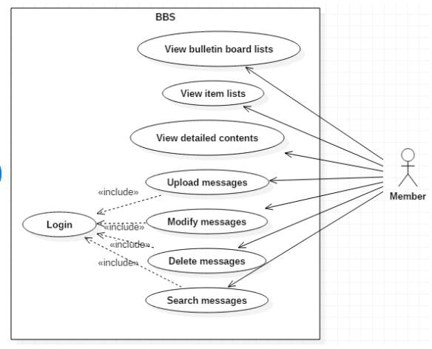

8. ARCHITECTURE DIAGRAM
The architecture diagram for a news application typically includes multiple layers that work together to provide the desired functionalities. At the base of the architecture, there is usually a database layer that stores all the data related to news articles, user profiles, and other relevant information. On top of the database layer, there is the server layer that handles the communication between the client-side application and the database. The server layer includes various components, such as web servers, application servers, and APIs, that enable the application to function smoothly. The client-side architecture includes multiple components, such as the user interface, data retrieval module, and presentation layer.
The user interface component provides the graphical user interface that allows users to interact with the application. The data retrieval module is responsible for retrieving data from the server layer and presenting it to the user in a structured format. The presentation layer includes various components, such as charts, tables, and graphs, that help the user to visualize the data in a more meaningful way. In addition to these core components, the architecture may include various other modules, such as security modules, caching modules, and analytics modules, that help to enhance the application's performance and usability.
By incorporating all these components into a single architecture, a news application can provide users with a seamless and engaging experience, making it easier for them to stay up-to-date with the latest news and trends. The architecture diagram consists of various layers, each with its specific responsibilities. The presentation layer is responsible for presenting information to the user, while the application layer is responsible for processing user input and communicating with the data layer. The data layer is responsible for storing and retrieving data, which includes the news articles and user preferences.
The presentation layer includes the user interface components, such as activity screens, widgets, and menus, that enable users to interact with the application. The application layer includes the business logic components, such as controllers, services, and managers, that handle user input and communicate with the data layer. The data layer includes the database and data access components, which manage and store the application's data.

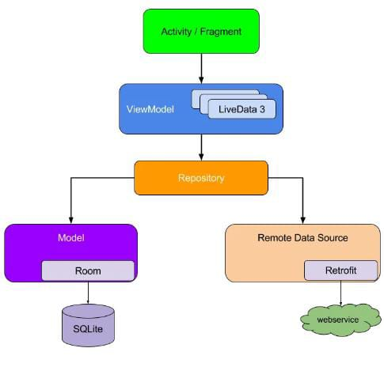

7.1 A CLEAN ARCHITECTURE DIAGRAM

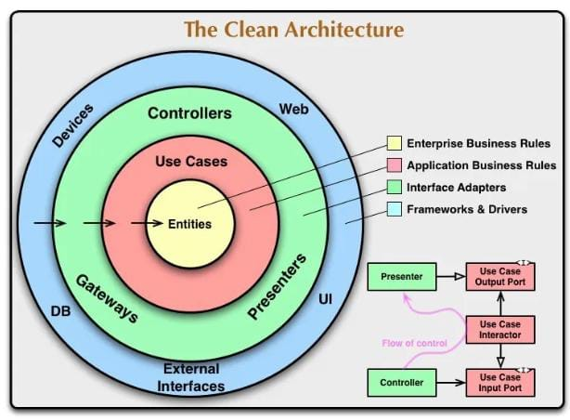

- SOURCE CODE
<manifest xmlns:android="http://schemas.android.com/apk/res/android" xmlns:tools="http://schemas.android.com/tools">
<uses-permission android:name="android.permission.INTERNET"/>
<uses-permission android:name="android.permission.ACCESS_WIFI_STATE"/>
<application android:allowBackup="true" android:dataExtractionRules="@xml/data_extraction_rules" android:fullBackupContent="@xml/backup_rules" android:icon="@drawable/news_app_icon" android:label="@string/app_name" android:supportsRtl="true" android:theme="@style/Theme.NewsHeadlines" tools:targetApi="31">
<activity android:name=".DisplayNews" android:exported="false" android:label="@string/title_activity_display_news" android:theme="@style/Theme.NewsHeadlines"/>
<activity android:name=".RegistrationActivity" android:exported="false" android:label="@string/title_activity_registration" android:theme="@style/Theme.NewsHeadlines"/>
<activity android:name=".MainPage" android:exported="false" android:label="@string/title_activity_main_page" android:theme="@style/Theme.NewsHeadlines"/>
<activity android:name=".LoginActivity" android:exported="true" android:label="@string/app_name" android:theme="@style/Theme.NewsHeadlines">
<intent-filter>
<action android:name="android.intent.action.MAIN"/>
<category android:name="android.intent.category.LAUNCHER"/>
</intent-filter>
</activity>
</application>
</manifest>
  - OUTPUT
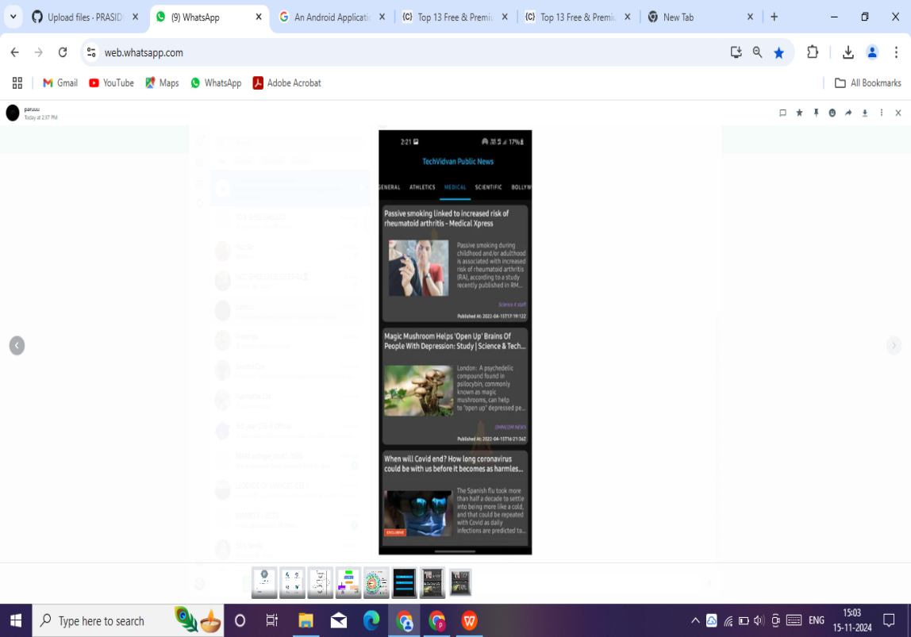
  - EXECUTION SCREENSHOT
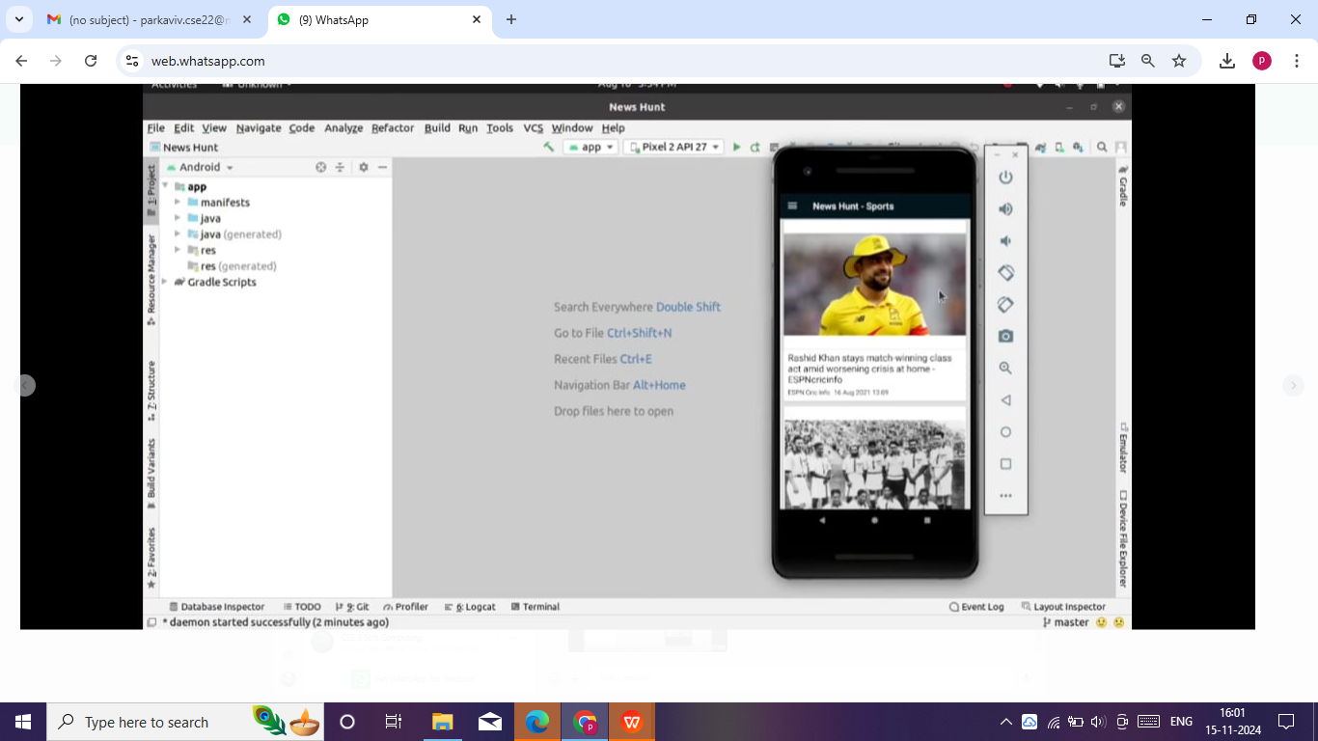
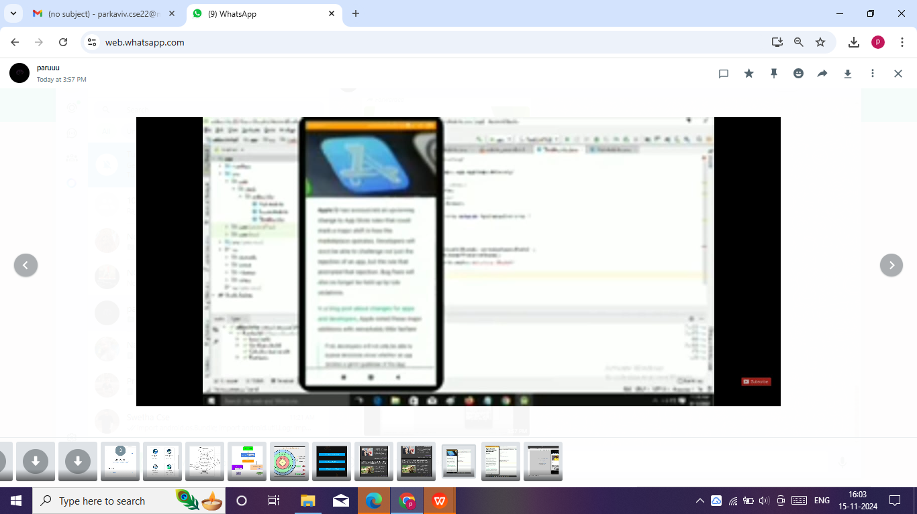
10. IMPLEMENTATION
10.1 Implementation Strategy
Implementation refers to the process of turning the design and planning of the Android news app into an actual working product. This involves a series of steps such as coding, testing, and integration of various components. The implementation phase requires skilled developers who are proficient in programming languages such as Java and Kotlin, and who can work with development tools such as Android Studio. During the implementation phase, developers will also need to ensure that the app is responsive, user-friendly, and optimized for performance. This involves following best practices and guidelines for app development, such as adhering to design patterns and ensuring proper use of resources. Additionally, developers will need to collaborate with the design team to ensure that the final product matches the original design vision and meets the functional and nonfunctional requirements. Once the implementation is complete, the app will undergo rigorous testing to ensure that it is ready for deployment to end-users. The News Content Personalization for Mobile Applicationsprovides a comprehensive review of the current state of the art in news content personalization for mobile applications. With the rapid growth of mobile devices and the increasing demand for personalized news, news providers are facing the challenge of delivering relevant content to users.
11. CONCLUSION
The deployment diagram also highlighted the various hardware components required for the app to function seamlessly, including the web server, database server, and mobile server. The app was developed using Android Studio, with PHP used as the programming language for the server-side development. The hardware specifications used for the development of the app were carefully chosen to ensure optimal performance and reliability. In conclusion, the Android news app is a perfect example of how technology can be leveraged to enhancelives. It provides with instant access to news from all over the world, keeping informed and connected. The use of various diagrams and testing techniques during the development phase ensured that the app was well-designed, efficient, and userfriendly. The app's deployment diagram highlighted the essential hardware components required for the app to function effectively. Overall, the Android news app is a welldeveloped and reliable app that will undoubtedly prove to be a valuable tool for keeping people informed in today's fast-paced world.
12.REFERNCES
[1] "Design and Development of a News Aggregator Application for Android" by T. A. Arumugam and S. K. Velumani (2021)
[2] "Design and Implementation of a Personalized News Recommendation System for Android" by Y. Lu et al. (2022)
[3] "A Framework for Developing News Recommender Systems for Mobile Devices" by S. Shah et al. (2022)
[4] "News Aggregator and Recommendation System for Android Using Natural Language Processing" by J. Lee et al. (2022)
[5] "User-Driven News Personalization in Mobile Applications" by M. Al-Saeed et al. (2023)
[6] "Design and Development of an Android News App with Augmented Reality Technology" by K. Tawil et al. (2023)

